Scenario 7: Instead of installing any applications can user access AWS via CLI??
- Yes, he can use Cloudshell.
- He needs to login to AWS console from there cloud shell. (few regions only have Cloudshell).
- https://docs.aws.amazon.com/cloudshell/latest/userguide/supported-aws-regions.html

step 1: create an user account in IAM
step 2: provide him aws console access and username and password.
Username - testuser
Step 3: since this user is an L1-support guy so I will provide him only readonly access to EC2.
Step 3: user needs to login to AWS Console via username and password and navigate to cloudshell.
Step 4: If the user is getting the below error message means cloudshell permission is not provided to the user
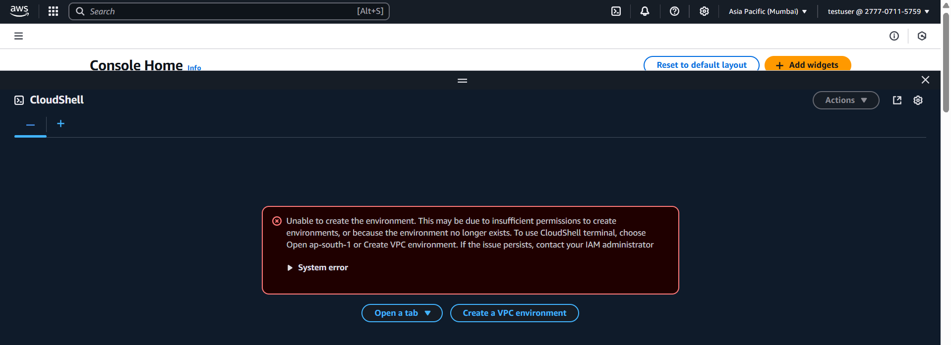

Step 5: As an administrator login to IAM> select the test user > under permissions > Add permissions
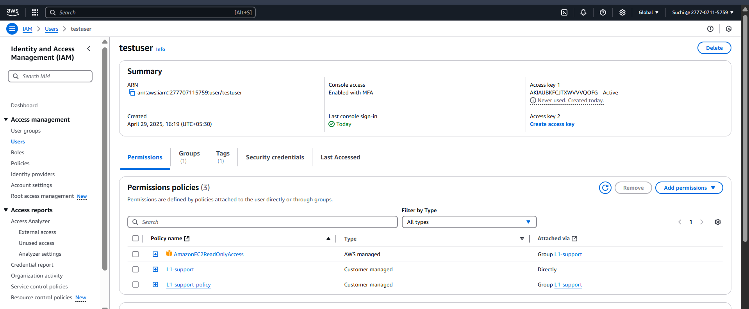
Step 6: Select attach policies directly and select the policy “AWSCloudShellfullAccess”
If there is already an permission attached to one of the groups, then you can select “add user to group option” and add user to that group
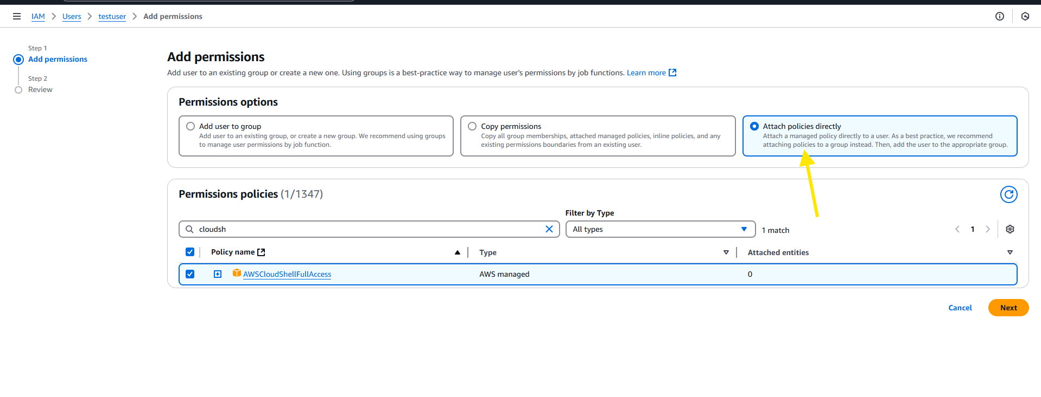
Step 7: review and Add permission
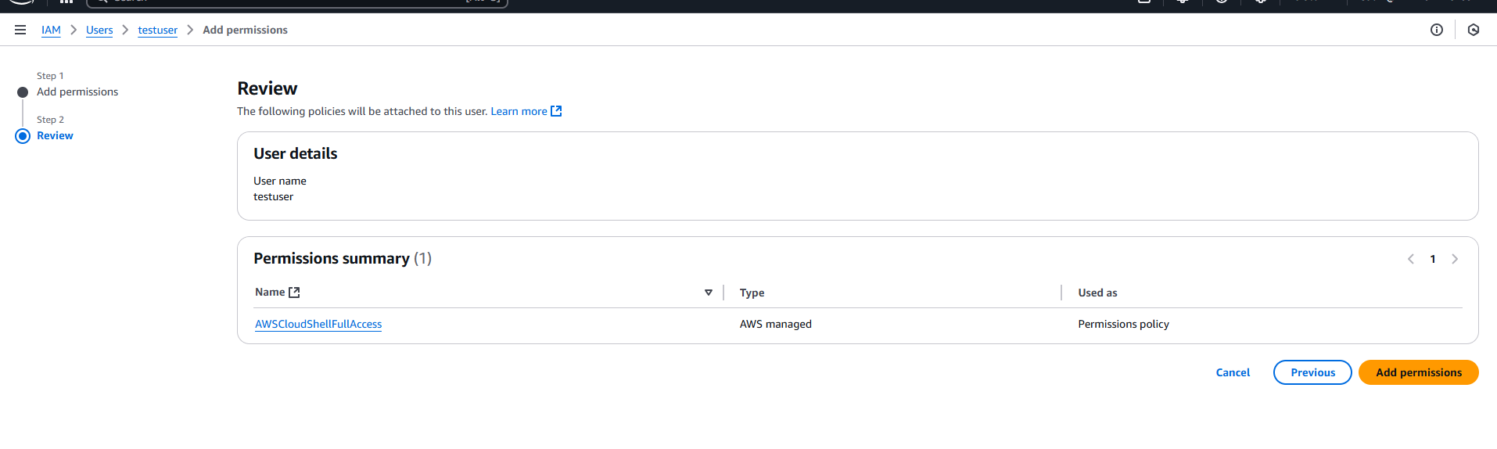
Step 8: ask user for the confirmation, he can refresh and validate.
Hurrah!
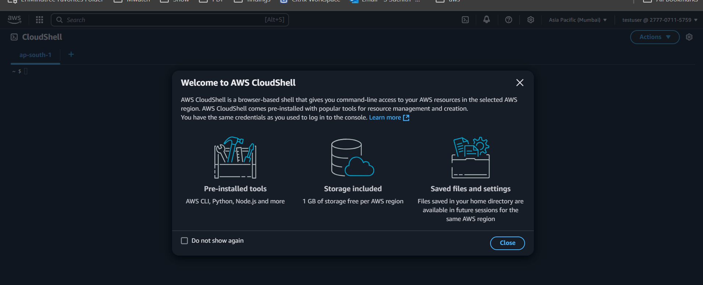

Steps to login to Cli and use L1 task
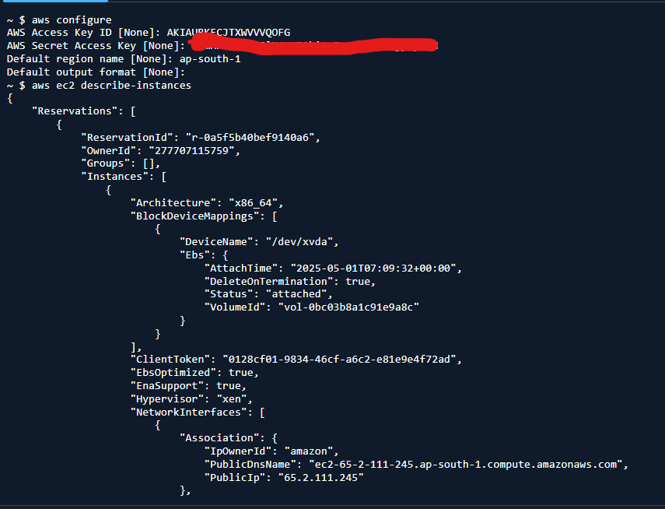

Points to be noted:
- Use access keys only if needed.
- Use the access keys only for access outside of the aws console (local machine)
- To use outside of the aws, need to install aws CLI.
- If you have created an IAM account, and provided that user with an cloudshell access, he can access the resource with the access keys.
- Note : why the usage of access keys is not recommended because it doesn’t ask for an MFA. Anybody with the access keys can use the resources so it’s not recommended to use access keys.
- Rather go for a cloudshell.

Steps to delete the access keys:
Step 1: locate the user account which you needs to delete the access keys
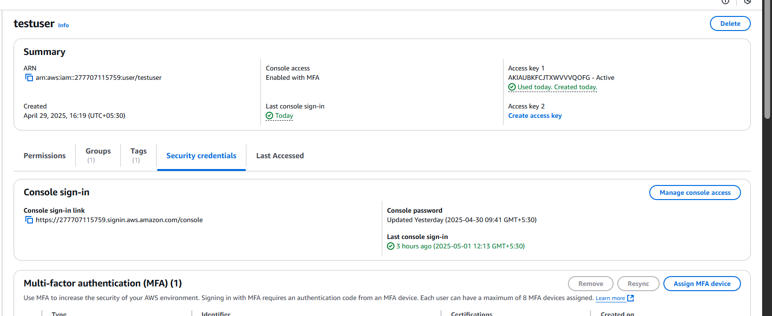

Step 2: under security credentials scroll down to access keys
Under actions > deactive and then delete
